**HOW TO DEVELOP A RESEARCH QUESTION**

**The PEO Model**

**Step 1: Defining the Terms of the Question**

|  |  |
| --- | --- |
| **POPULATION & PROBLEM (P)**  **What is the population/group affected by the phenomenon/ intervention that you propose to investigate?** |  |
| **EXPOSURE (E)**  **What is the phenomenon/ intervention that you propose to investigate?** |  |
| **OUTCOMES OR THEMES (O)**  **In what way do the members of the population perceive/experience the phenomenon/intervention/ problem that is under analysis?** |  |

**Step 2: Create Tentative Research Questions**

|  |  |
| --- | --- |
| **CREATE TENTATIVE RESEARCH QUESTIONS**  **Write-up several alternatives for formulating the Research Question based on the Terms identified in Step 1. See exemples below.** |  |

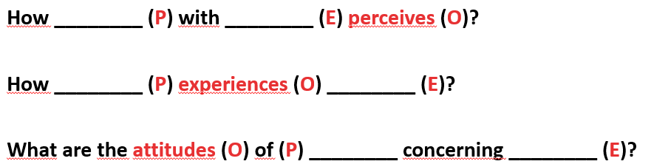**Examples:**

**Step 3: Choose the Best Option**

|  |  |
| --- | --- |
| **SPECIFY THE RESEARCH QUESTION** |  |