HOW TO DEVELOP A RESEARCH QUESTION

The PICO Model

Step 1: Defining the Terms of the Question

POPULATION & PROBLEM (P)

What is the population/group affected by the phenomenon/ intervention that you propose to investigate?

INTERVENTION OR EXPOSURE (I)

What is the phenomenon/ intervention that you propose to investigate?

COMPARISON / CONTROL (C)

What is the element of comparison (control group/alternative intervention) that effectively allows for the study of the impact of the phenomenon/intervention/problem?

OUTCOME (O)

What is the indicator/fact that allows measuring the impact of the phenomenon/intervention/problem that you propose to investigate?

Step 2: Create Tentative Research Questions

CREATE TENTATIVE RESEARCH QUESTIONS

Write-up several alternatives for formulating the Research Question based on the Terms identified in Step 1. See exemples below.

Examples:
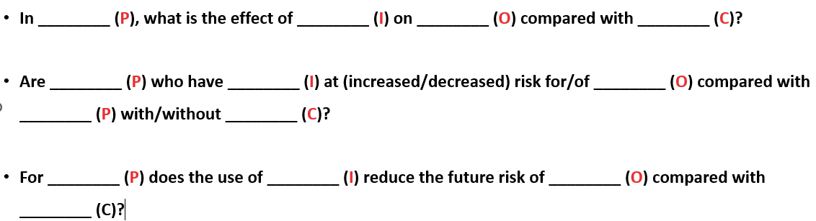

Step 3: Choose the Best Option

SPECIFY THE RESEARCH QUESTION

