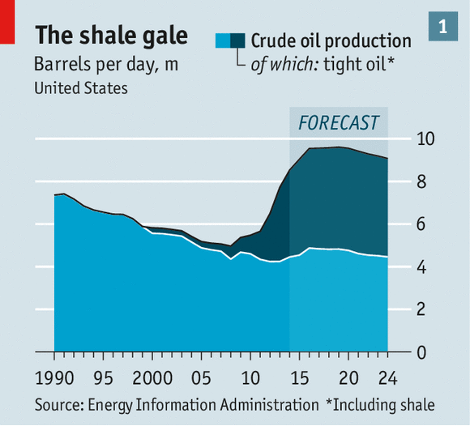 | Tight oil (also known as shale oil or light tight oil, abbreviated LTO) is petroleum that consists of light crude oil contained in petroleum-bearing formations of low permeability, often shale or tight sandstone.  en.wikipedia.org/wiki/Tight_oil
Figure 1

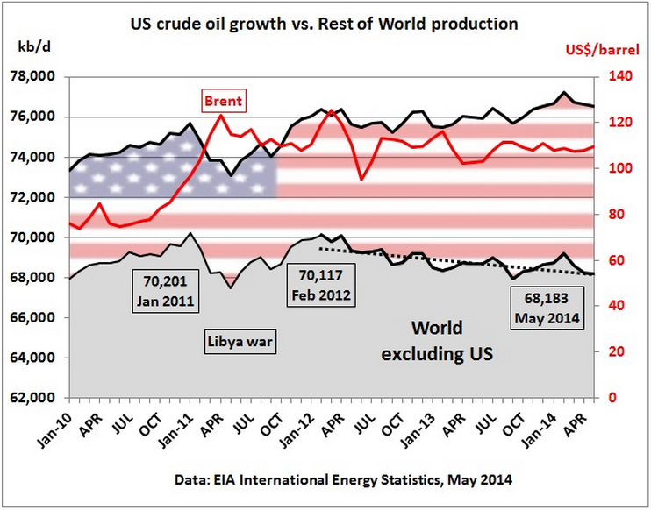
Figure 2

