[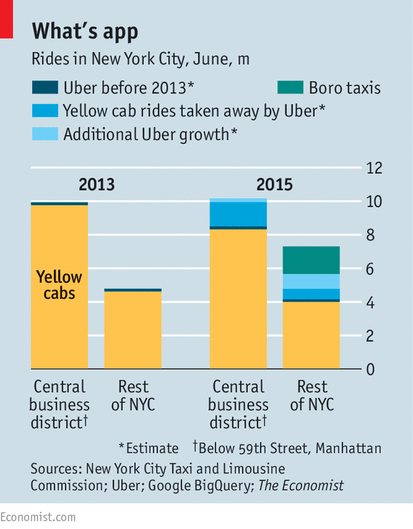](https://blogs.pugetsound.edu/econ/2015/10/06/uber-vs-taxis-in-new-york-city/)