[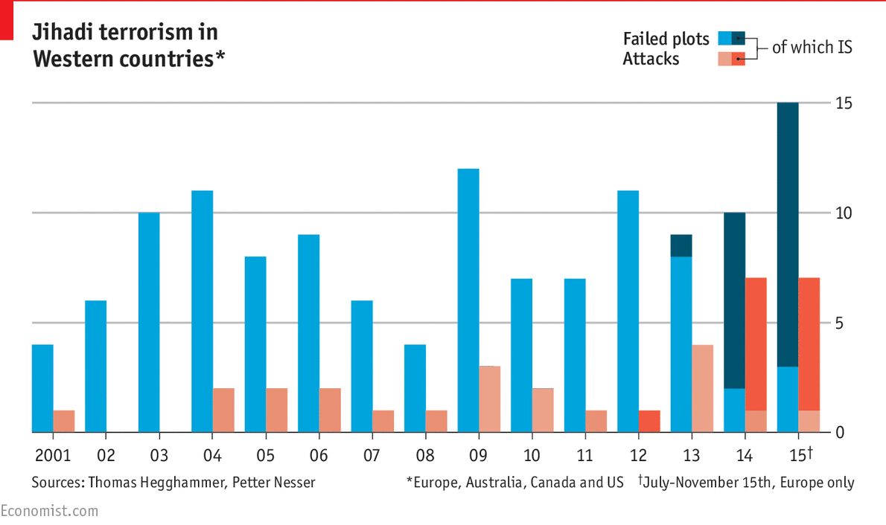](http://www.economist.com/blogs/graphicdetail/2015/11/daily-chart-12)