[](https://www.pinterest.com/fbbviv/illustration-political-cartoons/)

[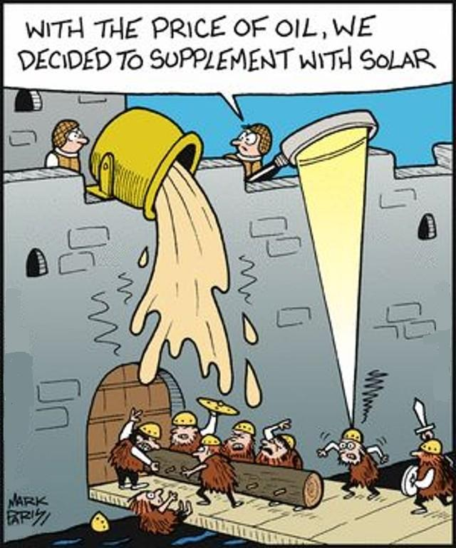](http://www.bartcop.com/2816.htm)