

**Master in Mathematical Finance**

**Interest Rate and Credit Risk Models**

**Exam – 18 January 2019**

Time: 2:15h

1. Let us assume that you have to model the term structure of interest rates of a given country or currency.
   1. Please explain the type of information usually employed and their main pros and cons. (1)

* Spot, forward or discount rates from zero-coupon bonds
* Usually there are not enough zero-coupon bonds => prices/yields of coupon-paying bonds are used and the yield curve is estimates/smoothed afterwards
* For the short-term, there are usually zero-coupon govt bonds (Treasury bills). However, these bonds don’t have a liquid secondary market => money market reference rates are often used instead, as they are quoted on a daily basis (assuming banks’ credit risk is similar to the Govt, at least in shorter maturities),
  1. Assuming that the graphical representation of the term structure suffers changes mostly in the level and the slope and that the volatility of interest rates is constant along time, please present, one static and one dynamic model to adequately estimate this term structure, as well as the reasons to choose these models. (2,5)
* Most changes in level and slope => 2 factors must be enough => DPR or NS as a static method and a 2-factor affine model may be used.
* Constant volatility => Vasicek-type model
  1. What could you conclude about the future behavior of interest rates if in a given period long-term interest rates increase more than short-term rates (2,0)?
* Expectations theory => higher expectations of short-term interest rates (in the pure version, we can assume that the forward is the expected value of the spot; in the non-pure version, we can only conclude that the expectations increased, but we don’t know the value of the expected future short rate, as we would have to quantify the risk premium, that is assumed to be nil in this version)
  1. Assuming that you’re managing a portfolio of 5-year Government bonds and you anticipate the interest rate shift mentioned in the previous question, how could you implement a hedging strategy using 3-year Government bonds, considering that all bonds are at the par value, have a redemption value of 1000 Euros and pay annual coupon rates of 2% and 1% (respectively for the 5-year and the 3-year maturities). (2,5/20)

Assuming 100 bonds

q = - (P x Dp) / (H x Dh)

Portfolio value = 100 5y bonds

Price of 5 year bond = 1000 (it is at par value)

5y bond Duration = 4,8

Price of 3 year bond = 1000 (it is at par value)

10y Bond Duration = 2,97

q = - (100000 x 4,8) / (H x Dh) = - (100000 x 4,81)/ (1000 x 2,97) = -161.85

* 1. Please discuss in which extent these Government bonds are riskier when their pay-offs are negatively correlated to the stochastic discount factor and how could their risk be related to the marginal utility of consumption (2,0)

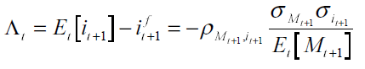

* Explain CCAPM => discount rate as the intertemporal marginal rate of substitution =>

in equilibrium the price of a financial asset is such that the utility loss from not consuming the income allocated to the financial asset correspondsto the discounted expected utility from consuming the pay-off of the financial asset inthe next period.

1. Please consider the following information on the share prices of PTP company.

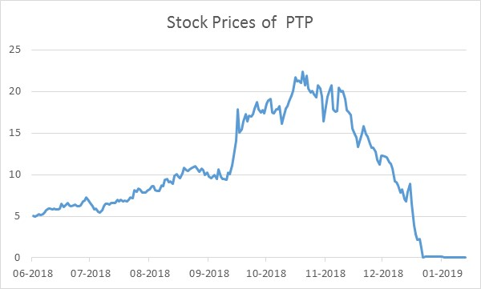

2.1. How do you interpret the chart above, concerning the probability of default of this company in its liabilities, by using a structural model? Please present the main assumptions, equations and limitations of the model to be used, as well as the information you would need to perform your assessment based on that model. (3,0)

- explain Merton model, namely the 2-equation system and how to reach there

2.2. Assuming that, at the beginning of the period illustrated in the chart, you had the following information available about the 1-year rating transition matrix from the statistics of a recognized rating agency, aggregating all information regarding investment and speculative grade ratings respectively in a rating class *I* and *S* (corresponding *D* to default), compute the 2-year probability of default of the company PTP if this company had then a rating classification of “I”, taking into consideration the potential rating migrations and interpret the result obtained. (2,5)

|  |  |  |  |
| --- | --- | --- | --- |
|  | I | S | D |
| I | 0,8 | 0,175 | 0,025 |
| S | 0,15 | 0,75 | 0,1 |

|  |  |  |
| --- | --- | --- |
| P(II)xP(ID)= | 0,02 | |
| P(IS)xP(SD)= | 0,0175 | |
| P(ID)xP(DD)= | 0,025 | |
| 2y PD =0,0625 | |  |

2.3. Considering that the default intensity follows a Poisson process, what would be the default intensity necessary to get the 1-year default rate for PTP at the same moment considered in the previous question and the corresponding expected time to default? (2,5)

*p(t )* = *e*−*λt -* probability of survival for *t* years (to be shown afterwards)

1*/λ -* expected time to default

1-0,025 = = *e*−*λt* ⬄ ln(1-0,025) = −*λt* ⬄ *λ=-*ln(1-0,025)/t => *λ=-*ln(1-0,025) =2,53% (as t=1)

1*/λ* = 39,5 years

2.4 Departing from the previous question, which additional information would you need to calculate the cumulative probability of default of PTP for *t* years assuming that default follows a Cox process and how would you calculate it. (2,0)

* Variations of ** along time