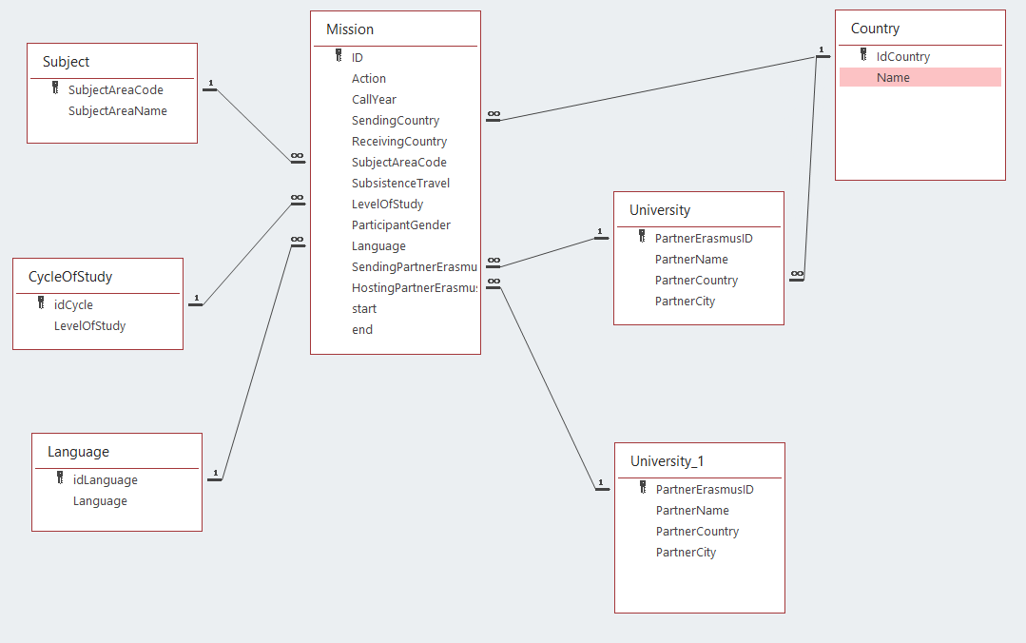

Select
From
Where
- List all the universities:

- List the name of all the universities’ names

- List all the universities from PT

- List all the universities from Portugal

- List all Countries involved in the program

Aggregate functions
Select count(*)
From
Where

- Number of countries involved in the program

- Number of missions involving Portuguese students

- List subject areas

- Number of subjects

- Number of missions of economics

- Number of missions by subject

