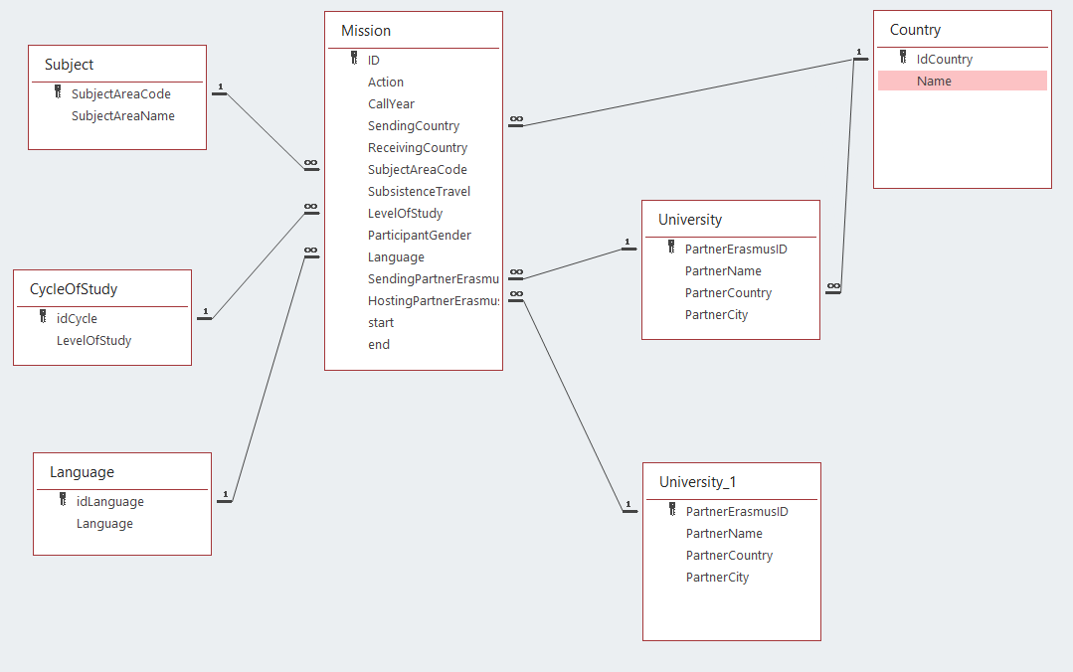
Select
From
Where
- List all the universities:

SELECT *
From University

- List the name of all the universities’ names

SELECT PartnerName
From University

- List all the universities from PT

SELECT PartnerName
From University
Where PartnerCountry="PT"

- List all the universities from Portugal

SELECT PartnerName
From University, Country
Where Name="Portugal" and PartnerCountry=idCountry

- List all Countries involved in the program

SELECT *
From Country
Aggregate functions
- Number of countries involved in the program
SELECT count(*)
- Number of missions involving Portuguese students
SELECT count(*)
From Mission, Country
Where idCountry=SendingCountry and Name="Portugal"

SELECT count(*)
From Mission, Country, University
Where PartnerErasmusID=SendingPartnerErasmusID and PartnerCountry=idCountry and Name="Portugal"
- List subject areas
Select subjectareaname
From Subject
- Number of subject

Select count(subjectareaname)
From Subject

10 Number of missions of economics

Select count(*)
From Subject, Mission
Where Subject.subjectareacode = Mission.subjectareacode and subjectareaname ="Economics"

- Number of missions by subject
Select count(*)
From Subject, Mission
Where Subject.subjectareacode = Mission.subjectareacode
group by subjectareaname

Select subjectareaname, count(*)
From Subject, Mission
Where Subject.subjectareacode = Mission.subjectareacode
group by subjectareaname

